AWS provides a robust suite of tools that enable organizations to automate security operations and enforce governance across multiple accounts, particularly within an AWS Organization. These tools leverage machine learning, policy enforcement, and integration capabilities to enhance security posture and streamline compliance efforts.

Tools (Old) Grouping
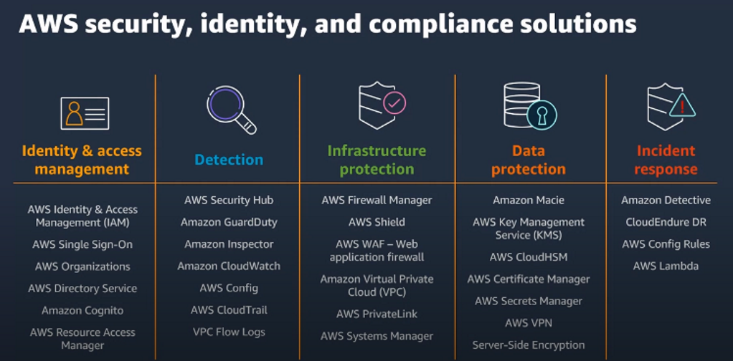
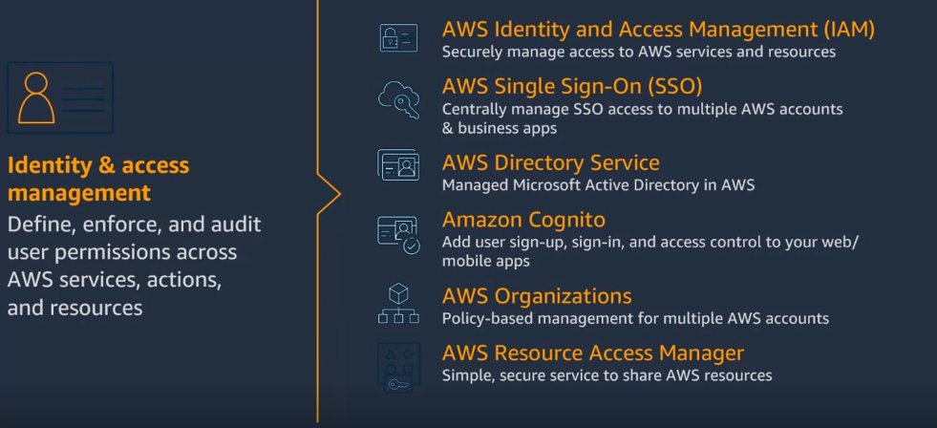
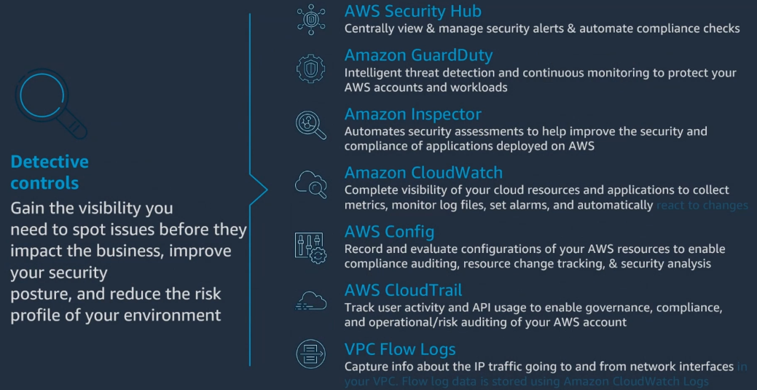
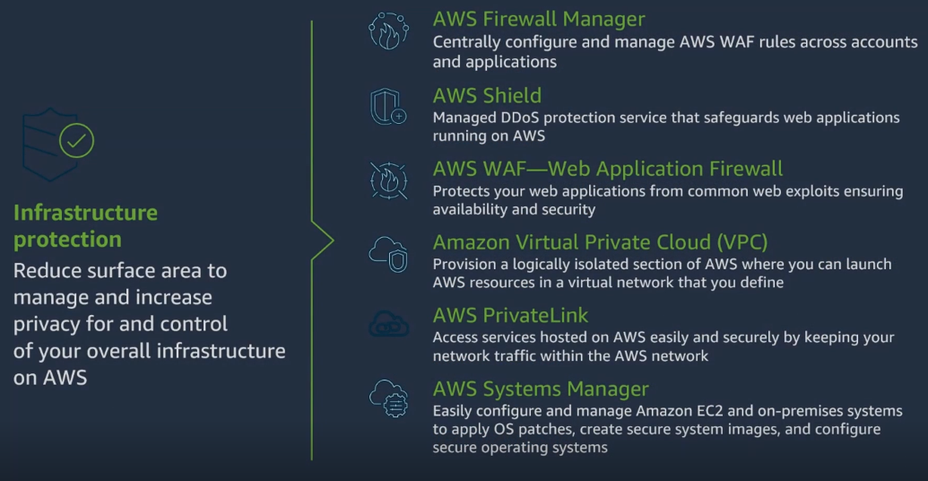
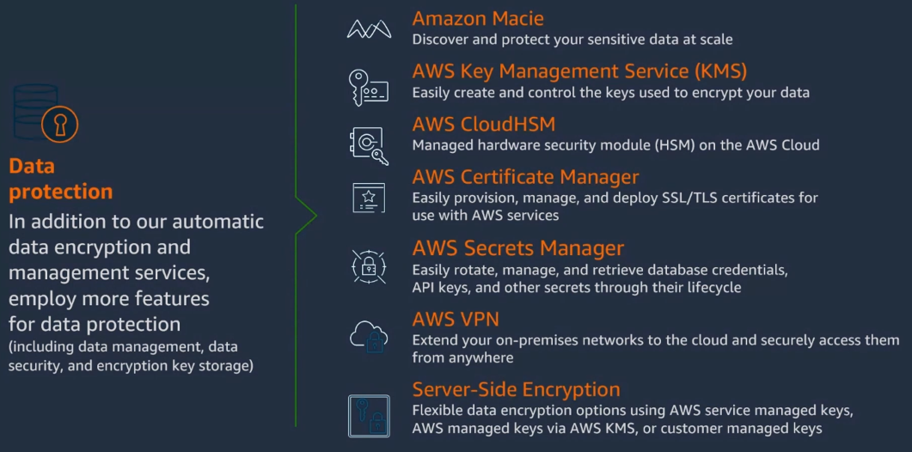
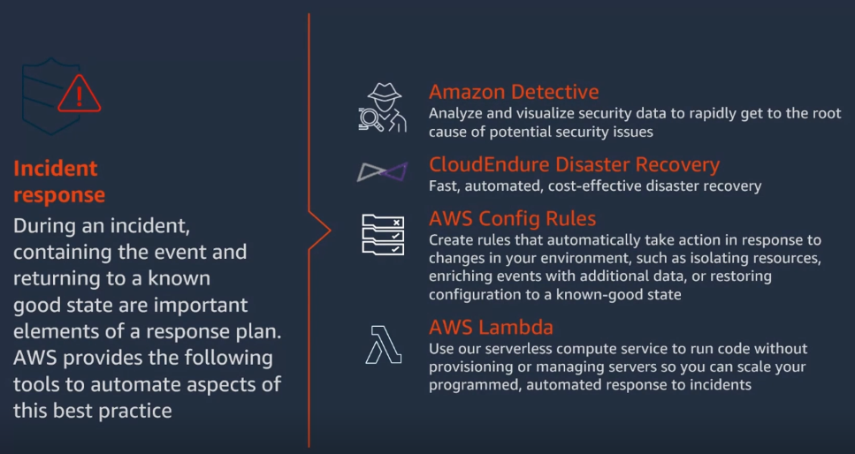

AWS Certified Security Specialty Course Study Guide
Table of Contents
- Domain 1 – Threat Detection and Incident Response
- Domain 2 – Security Logging and Monitoring
- Domain 3 – Infrastructure Security
- Domain 4 – Identity and Access Management
- Domain 5 – Data Protection
- Domain 6 – Management and Security Governance

Elements - Insights
- What is the primary difference between a GuardDuty Trusted IP List and a Threat IP List? A GuardDuty Trusted IP List consists of IP addresses and CIDR ranges that are considered safe, for which GuardDuty will not generate findings. Conversely, a Threat IP List contains known malicious IP addresses, and GuardDuty will generate findings based on activity from these lists.
- When performing penetration tests on AWS, which activities are explicitly prohibited? Explicitly prohibited activities include DNS zone walking via Amazon Route 53 Hosted Zones, Denial of Service (DoS) or Distributed Denial of Service (DDoS) attacks (simulated or real), port flooding, protocol flooding, and request flooding (e.g., login or API request flooding). For any other simulated events not on the allowed list, prior contact with AWS Security is required.
- Explain the main difference in how Security Groups and Network Access Control Lists (NACLs) operate regarding statefulness and rule evaluation. Security Groups operate at the instance level, are stateful (return traffic is automatically allowed), and support only allow rules, with all rules evaluated before allowing traffic. NACLs operate at the subnet level, are stateless (return traffic must be explicitly allowed, including ephemeral ports), support both allow and deny rules, and evaluate rules in order (lowest to highest) with the first match winning.
- How do VPC Endpoints enhance security for connecting to AWS services, and what are the two main types? VPC Endpoints allow connecting to AWS Services using a private network instead of the public internet, removing the need for an Internet Gateway or NAT Gateway and thus reducing attack surface. The two main types are VPC Endpoint Gateway (for S3 and DynamoDB) and VPC Endpoint Interface (for most other AWS services, using Elastic Network Interfaces).
- Describe the purpose of an IAM Permission Boundary and for which IAM entities it is supported. An IAM Permission Boundary is an advanced feature that sets the maximum permissions an IAM entity (user or role) can ever have, regardless of other attached identity-based policies. It acts as an "allow list" for permissions, meaning the effective permissions are the intersection of the entity's identity-based policies and the permission boundary. It is supported for IAM users and roles, but not groups.
- What is the "Confused Deputy Problem," and how does AWS's External ID feature help mitigate it? The "Confused Deputy Problem" occurs when a privileged entity (the deputy) is tricked by a less-privileged entity into performing an action that the less-privileged entity is not authorized to do. AWS's External ID feature helps solve this by requiring a specific value to be passed to the AssumeRole API, ensuring that only the intended third party (who knows the External ID) can assume your IAM role, preventing other customers from tricking them.
- What are KMS Multi-Region Keys, and what is their primary use case in a global application scenario? KMS Multi-Region Keys are identical KMS keys that exist in different AWS Regions and can be used interchangeably, sharing the same key ID and material. Their primary use case is in global applications, such as client-side encryption for DynamoDB Global Tables or Aurora Global Database, where data encrypted in one region can be decrypted in another without re-encryption or cross-region API calls, reducing latency and complexity.
- Explain the difference between AWS Owned Keys, AWS Managed Keys, and AWS Customer Managed Keys in AWS KMS regarding key policy management. AWS Owned Keys are KMS keys owned and managed by AWS for use across various AWS services, and their key policies cannot be viewed or changed. AWS Managed Keys (e.g., aws/ebs) are KMS keys managed by AWS for specific services on your behalf; you can view their key policies but cannot change them. AWS Customer Managed Keys (CMKs) are KMS keys that you create, own, and manage, allowing you to view and edit their key policies fully.
- What is the purpose of S3 Glacier Vault Lock, and how does it relate to the WORM model? S3 Glacier Vault Lock allows users to deploy and enforce a "Write Once Read Many" (WORM) model on their Glacier vaults. This is achieved by creating a Vault Lock Policy that, once locked, becomes immutable and cannot be changed or deleted. This feature is crucial for meeting strict regulatory and compliance requirements for data retention and immutability.
- How does an AWS Lambda function in a VPC get Internet access, and what is the default behavior? By default, a Lambda function is launched outside your VPC in an AWS-owned VPC and has internet access. When a Lambda function is deployed into your VPC (private subnets), it loses direct internet access. To regain internet access, the Lambda function must route its traffic through a NAT Gateway (or NAT Instance) in a public subnet, or utilize VPC Endpoints for private access to other AWS services.
Essay Questions
- Compare and contrast AWS GuardDuty, VPC Flow Logs, and VPC Traffic Mirroring as security monitoring and logging tools. Discuss their primary use cases, the type of data they collect, and how they contribute to threat detection and incident response in an AWS environment.
- AWS Identity and Access Management (IAM) is foundational to security in AWS. Explain the comprehensive policy evaluation logic used by IAM, including the roles of explicit denies, explicit allows, permission boundaries, Organizations SCPs, and session policies. Provide scenarios where understanding this hierarchy is critical for secure access control.
- Detail the various methods and services AWS provides for data encryption at rest and in transit (e.g., SSE-S3, SSE-KMS, SSE-C, CloudHSM, client-side encryption, KMS Multi-Region keys). Discuss the trade-offs and appropriate use cases for each, considering factors like key management, compliance, performance, and cost.
- Discuss the differences between Security Groups and Network Access Control Lists (NACLs) in AWS VPC. Explain their operational levels, statefulness, rule processing, and typical use cases. Elaborate on how you would configure them in conjunction to build a robust multi-tier application architecture, providing examples of inbound and outbound rules for different tiers.
- Explain the concept of Attribute-Based Access Control (ABAC) in AWS IAM and how it differs from traditional Role-Based Access Control (RBAC). Discuss the benefits of implementing ABAC, especially in rapidly growing environments, and provide an example of how tags can be leveraged to grant or deny access based on principal and resource attributes.
Glossary of Key Terms
- AWS Acceptable Use Policy (AUP): A policy that governs your use of AWS services, prohibiting illegal, fraudulent, or harmful activities, and misuse of services.
- AWS Control Tower: A service that provides a well-architected multi-account AWS environment with ongoing governance, using preventive (SCPs) and detective (AWS Config) guardrails.
- AWS Data Lifecycle Manager (DLM): A service that automates the creation, retention, and deletion of Amazon EBS snapshots and AMIs.
- AWS Nitro Enclaves: An isolated compute environment for processing highly sensitive data within Amazon EC2 instances, providing enhanced security.
- AWS Organizations: A service that helps you centralize governance and management for multiple AWS accounts, allowing you to create organizational units (OUs) and apply policies across accounts.
- AWS Resource Access Manager (RAM): A service that allows you to securely share AWS resources that you own with other AWS accounts or within your AWS Organization, avoiding resource duplication.
- AWS Signer: A fully managed code-signing service that ensures the trust and integrity of your code by validating it against a digital signature.
- Attribute-Based Access Control (ABAC): An authorization strategy that defines permissions based on attributes (tags) associated with users, roles, and AWS resources.
- CloudFront Signed URL / Signed Cookies: Mechanisms used to restrict viewer access to content delivered through Amazon CloudFront, allowing access for a limited time or to specific users.
- CloudHSM: A hardware security module (HSM) service that allows you to generate and manage your own encryption keys within FIPS 140-2 Level 3 validated HSMs in the AWS cloud.
- Confused Deputy Problem: A security vulnerability where a privileged entity performs actions inadvertently on behalf of a less-privileged entity, leading to unauthorized access.
- CORS (Cross-Origin Resource Sharing): A security mechanism that allows web browsers to make requests to a domain other than the one from which the page was loaded. Required for cross-origin S3 access.
- Cost Explorer: An AWS tool that allows you to visualize, understand, and manage your AWS costs and usage over time, including forecasting.
- DDoS (Distributed Denial of Service): A malicious attempt to disrupt normal traffic of a targeted server, service, or network by overwhelming the target or its surrounding infrastructure with a flood of Internet traffic from multiple sources.
- DNS Poisoning (Spoofing): A cyberattack technique used to redirect legitimate internet traffic to malicious websites by corrupting DNS records.
- Drift (CloudFormation): A state where the current configuration of an AWS resource differs from its definition in the CloudFormation stack template, often due to manual changes.
- EC2Rescue Tool: A tool for Windows Server EC2 instances that helps diagnose and troubleshoot common issues, collect log files, and provide suggestions.
- External ID: A piece of data passed to the AssumeRole API when granting third-party access to AWS resources, used to prevent the Confused Deputy problem.
- GuardDuty: An AWS threat detection service that continuously monitors for malicious activity and unauthorized behavior to protect your AWS accounts and workloads.
- Guardrail (Control Tower): A high-level rule that provides ongoing governance for an AWS Control Tower environment, enforced using SCPs (preventive) or AWS Config (detective).
- IAM Permission Boundary: An advanced IAM feature that uses a managed policy to set the maximum permissions an IAM user or role can ever have.
- IAM Policy Evaluation Logic: The hierarchy of rules AWS IAM uses to determine if a request is allowed or denied, considering explicit denies, explicit allows, and various policy types.
- KMS (Key Management Service): An AWS service that makes it easy for you to create and manage cryptographic keys and control their use across a wide range of AWS services and in your applications.
- KMS Multi-Region Keys: Identical KMS keys in different AWS Regions that can be used interchangeably for encryption and decryption, facilitating global applications.
- NACL (Network Access Control List): A stateless firewall that controls inbound and outbound traffic at the subnet level within a VPC.
- Penetration Testing: Authorized simulated cyberattacks against an AWS infrastructure to evaluate its security posture.
- Redshift – in-DB Security: Mechanisms for managing user access and authentication within an Amazon Redshift database, including IAM authentication and temporary credentials.
- Resource Policy: A policy attached to a resource (e.g., S3 bucket, SQS queue, Secrets Manager secret) that specifies who can access it and what actions they can perform.
- S3 Access Points: Named network endpoints attached to S3 buckets that simplify managing data access at scale for different applications or teams.
- S3 Glacier Vault Lock: A feature for Amazon S3 Glacier vaults that allows you to lock a policy for future edits, ensuring data immutability and compliance with WORM models.
- S3 Object Lock: A feature that prevents objects from being deleted or overwritten for a fixed amount of time or indefinitely, supporting WORM policies in S3 buckets.
- Security Group: A stateful firewall that controls inbound and outbound traffic for EC2 instances at the instance level.
- Service Catalog: An AWS service that allows organizations to create and manage catalogs of IT services that are approved for use on AWS.
- Secrets Manager: An AWS service that helps you protect access to your applications, services, and IT resources by rotating, managing, and retrieving database credentials, API keys, and other secrets throughout their lifecycle.
- SSM (Systems Manager): An AWS service that helps you automate operational tasks across your AWS resources, including Patch Manager, Run Command, and Parameter Store.
- STS (Security Token Service): An AWS service that enables you to create and provide trusted users with temporary, limited-privilege credentials to access your AWS resources.
- VPC Endpoint Gateway: A type of VPC endpoint that provides private connectivity to S3 and DynamoDB from within your VPC.
- VPC Endpoint Interface: A type of VPC endpoint that provides private connectivity to most AWS services from within your VPC via Elastic Network Interfaces (ENIs).
- VPC Flow Logs: A feature that captures information about the IP traffic going to and from network interfaces in your VPC, useful for security, monitoring, and troubleshooting.
- VPC Network Access Analyzer: A tool that helps you identify potential network paths to/from your resources and evaluate them against defined network access requirements.
- VPC Traffic Mirroring: A feature that allows you to capture and inspect network traffic in your VPC by routing it to security appliances for content inspection and threat monitoring.
- Well-Architected Framework: An AWS framework that provides guidance on how to build secure, high-performing, resilient, and efficient infrastructure for your applications.

Automating Security Operations
Several AWS services are designed to automate various aspects of security operations:
- Amazon GuardDuty offers intelligent threat discovery to protect your AWS accounts. It uses machine learning algorithms, anomaly detection, and third-party data to analyze input from sources like CloudTrail Event Logs, VPC Flow Logs, and DNS Logs. GuardDuty can protect against various threats, including cryptocurrency attacks. When findings (potential security issues) are detected, EventBridge rules can be set up to automate responses, such as sending notifications to SNS or triggering AWS Lambda functions for remediation. GuardDuty can be managed across multiple accounts, with an administrator account able to manage GuardDuty, findings, suppression rules, trusted IP lists, and threat lists for associated member accounts. Suppression rules can filter and archive low-value or false-positive findings.
- AWS Security Hub acts as a central security tool that aggregates alerts and findings from various AWS services (e.g., GuardDuty, Inspector, Macie, IAM Access Analyzer, Config) and AWS partner tools into predefined or custom formats. It provides integrated dashboards to show current security and compliance status. Security Hub also allows for cross-Region aggregation of findings, insights, and security scores. You can define custom actions to automate responses and remediation to selected findings directly from the Security Hub Console, utilizing EventBridge.
- Amazon Detective helps in analyzing, investigating, and quickly identifying the root cause of security issues or suspicious activities. It automatically collects and processes event data from VPC Flow Logs, CloudTrail, and GuardDuty to create a unified view and produces visualizations for deeper analysis, complementing the identification of issues by GuardDuty, Macie, and Security Hub.
- Amazon Inspector provides automated security assessments for EC2 instances, container images pushed to Amazon ECR, and Lambda functions. It identifies software vulnerabilities and unintended network accessibility, associating a risk score with vulnerabilities for prioritization. Inspector sends findings to AWS Security Hub and Amazon EventBridge for reporting and integration into automated workflows.
- AWS Systems Manager (SSM) offers features that automate operational tasks, which can be critical for security.
  - Run Command allows you to execute scripts or commands across multiple instances without needing SSH, integrating with IAM and CloudTrail, and sending output to S3 or CloudWatch Logs.
  - Automation simplifies maintenance and deployment tasks for EC2 instances and other AWS resources using predefined or custom runbooks, which can be triggered manually, by EventBridge, on a schedule (Maintenance Windows), or by AWS Config for rules remediation.
  - Patch Manager automates OS and application updates, and security patches for managed instances, supporting both EC2 and on-premises servers. Patch compliance reports can be sent to S3.
  - Session Manager provides a secure shell to instances without requiring SSH access, bastion hosts, or SSH keys, and logs connections and executed commands to S3 or CloudWatch Logs.
- CloudWatch Alarms and Amazon EventBridge are fundamental for automating responses. CloudWatch Alarms can trigger notifications (SNS) or actions (EC2 actions, Auto Scaling) based on metrics. EventBridge (formerly CloudWatch Events) enables event-driven architectures, allowing you to react to events from AWS services (like CloudTrail API calls) or custom applications to trigger Lambda functions, send messages, or initiate SSM Run Commands.
- AWS WAF allows you to define Web Access Control Lists (Web ACLs) to protect web applications from common web exploits at Layer 7, such as SQL injection and Cross-Site Scripting (XSS). It supports rate-based rules to automatically block malicious IPs. Logs from WAF can be sent to CloudWatch Logs, S3, or Kinesis Data Firehose for analysis.
- AWS Network Firewall protects your entire Amazon VPC with Layer 3 to Layer 7 protection, inspecting traffic in any direction. It supports thousands of rules for IP & port filtering, protocol blocking, and general pattern matching. It can also send logs of rule matches to Amazon S3, CloudWatch Logs, or Kinesis Data Firehose, enabling automated responses to detected threats.
- AWS Signer is a managed code-signing service that ensures the trust and integrity of your code, particularly for AWS Lambda functions. It allows you to digitally sign Lambda deployment packages and enforce that only trusted code runs, helping to prevent unauthorized code execution.

Enforcing Governance Across Accounts
Maintaining a consistent security and compliance posture across multiple AWS accounts is crucial, and several tools facilitate this governance:
- AWS Organizations is a global service that allows you to centrally manage and govern multiple AWS accounts. It provides Consolidated Billing and pricing benefits from aggregated usage. The most significant governance feature is Service Control Policies (SCPs), which are IAM policies applied to Organizational Units (OUs) or accounts to restrict the maximum permissions that users and roles within those accounts can have. SCPs do not apply to the management account and require explicit allow from the root through each OU in the direct path to the target account.
- AWS Security Hub, as mentioned, supports AWS Organizations integration, allowing it to manage all accounts within the Organization and automatically detect new accounts. By default, the Organization's management account is the Security Hub administrator, with the option to delegate this role. Security Hub also enforces security standards like CIS AWS Foundations and PCI DSS by generating findings and continuous checks against their rules.
- AWS Config is vital for auditing and recording compliance of your AWS resources. It records configurations and changes over time, helping to answer questions about security group access or public S3 buckets. Config Rules can be AWS managed or custom (defined in Lambda) and can be triggered by configuration changes or at regular intervals. It can automate remediation of non-compliant resources using SSM Automation Documents. AWS Config can aggregate data across multiple accounts and Regions, providing a centralized view of compliance.
- AWS Control Tower is designed to set up and govern a secure and compliant multi-account AWS environment based on best practices. It automates environment setup and ongoing policy management through guardrails. Guardrails can be preventive (using SCPs) or detective (using AWS Config) to enforce policies and detect violations. Control Tower automatically sets up AWS Organizations and integrates with AWS Service Catalog for controlled account provisioning.
- AWS Firewall Manager enables centralized management of security rules and policies across all accounts in an AWS Organization. It can deploy WAF rules, AWS Shield Advanced protections, Security Groups for EC2/ALB/ENI, AWS Network Firewall policies, and Route 53 Resolver DNS Firewall rules. Policies applied through Firewall Manager are automatically enforced on new resources as they are created in any account within the Organization, ensuring consistent security posture.
- IAM Access Analyzer helps identify which resources are shared externally (outside a defined "Zone of Trust," typically the AWS Account or Organization). It generates findings for external access, aiding in preventing unintended data exposure. It also includes policy validation against best practices and policy generation based on CloudTrail logs to ensure least privilege.
- AWS Audit Manager simplifies assessing risk and compliance by continuously auditing AWS service usage and preparing audit-ready reports. It integrates with Security Hub, Config, and Control Tower, and can run over multi-account via AWS Organizations.
- AWS Organizations Tag Policies help standardize tags across resources, defining tag keys and allowed values. This is crucial for cost allocation tags and Attribute-Based Access Control (ABAC), which allows for fine-grained permissions based on user attributes matching resource tags, enabling scalability in rapidly-growing environments.
- AWS Resource Access Manager (RAM) allows you to share certain AWS resources (like VPC Subnets, Transit Gateway, Route53 Resolver Rules) that you own with other AWS accounts or within your Organization, preventing resource duplication and enabling consistent network configurations while maintaining account isolation for resource management.
- KMS Key Policies are resource-based policies that control access to KMS keys. They are crucial for cross-account access to KMS keys, defining who can administer or use the key for cryptographic operations. This enables centralized management of encryption keys across an organization.
- S3 Bucket Policies and S3 Access Points offer granular control over S3 data access. Bucket policies can enforce rules like requiring HTTPS for all requests or blocking access from specific IP addresses. S3 Access Points simplify security management for large S3 buckets by allowing you to create distinct access points with their own policies, effectively managing access to specific data subsets or for different applications. Access points can also be restricted to a VPC, enhancing network security.

AWS Config
AWS Config is a crucial AWS service designed for auditing and recording the compliance of your AWS resources. It functions by continuously recording configurations and changes over time for your AWS resources. This capability helps answer important security and compliance questions, such as whether security groups have unrestricted SSH access or if S3 buckets are publicly accessible.
Here are the key aspects of AWS Config:
- Core Purpose & Functionality
  - It helps with auditing and recording compliance of your AWS resources.
  - It records configurations and changes over time.
  - You can receive alerts (SNS notifications) for any changes detected by Config.
  - It allows you to view the compliance of a resource over time.
  - You can view the configuration of a resource over time.
  - It also enables you to view CloudTrail API calls related to a resource over time.
- Config Rules
  - AWS Config uses Config Rules to evaluate resource configurations.
  - These can be AWS managed rules (over 75 available) or custom rules defined in AWS Lambda.
  - Rules can be triggered in two ways:
    - For each configuration change.
    - At regular time intervals.
  - It's important to note that AWS Config Rules do not prevent actions from happening; they only detect and report non-compliance.
- Automated Remediation
  - AWS Config can automate the remediation of non-compliant resources.
  - This is achieved by using SSM Automation Documents, which can be AWS-managed or custom.
  - You can configure remediation retries if a resource remains non-compliant after an automated remediation attempt.
- Notifications
  - EventBridge can be used to trigger notifications when AWS resources become non-compliant.
  - Configuration changes and compliance state notifications can also be sent to SNS.
- Multi-Account and Multi-Region Aggregation
  - AWS Config is a per-region service.
  - However, it can aggregate data across multiple accounts and regions.
  - An aggregator is created in a central account to collect data from various source accounts and regions.
  - When used with AWS Organizations, individual authorization is not needed for aggregation.
  - Rules can be deployed to multiple target accounts using CloudFormation StackSets.
  - Configuration data can be stored in S3 for analysis by Athena.
- Integrations
  - AWS Security Hub aggregates alerts and findings from various AWS services, including Config. Security Hub uses AWS Config to perform its security checks and requires Config to be enabled on all accounts.
  - AWS Control Tower uses AWS Config for detective guardrails to identify policy violations, such as detecting whether MFA for the root user is enabled.
  - AWS Audit Manager integrates with Config for continuous auditing of AWS service usage to simplify risk assessment and compliance.
- Use Cases/Examples
  - Auditing IAM Policies.
  - Detecting if CloudTrail has been disabled.
  - Identifying EC2 instances created with unapproved AMIs.
  - Detecting if Security Groups are open to the public.
  - Identifying if an Internet Gateway is added to an unauthorized VPC.
  - Detecting if EBS volumes are encrypted.
  - Identifying if RDS databases are public.
  - Automating the rotation of aged IAM Access Keys using access-keys-rotated rule and SSM Automation.

AWS Security Hub
AWS Security Hub is a central security tool designed to manage security across multiple AWS accounts and automate security checks. It provides integrated dashboards that show the current security and compliance status, enabling quick action.
Here's a detailed breakdown of AWS Security Hub based on the sources:
- Core Purpose and Aggregation
  - Security Hub automatically aggregates alerts and findings from various AWS services and AWS partner tools. These findings are received in a predefined format called the AWS Security Finding Format (ASFF).
  - It acts as a central point to collect potential issues and findings from services like AWS Config, GuardDuty, Inspector, Macie, IAM Access Analyzer, AWS Systems Manager, AWS Firewall Manager, and AWS Health, as well as AWS Partner Network Solutions.
- Prerequisites and Integration with AWS Config
  - A crucial prerequisite for Security Hub to function is that AWS Config must first be enabled on all accounts. Security Hub does not manage AWS Config itself.
  - Security Hub uses AWS Config to perform its security checks. For example, if an AWS Config rule identifies a non-compliant resource, this non-compliance can be reported as a finding in Security Hub [conversational history].
- Integration with GuardDuty
  - The integration with GuardDuty is automatically enabled when Security Hub is activated, though it can be disabled.
  - GuardDuty findings are automatically sent to Security Hub, typically within 5 minutes, in the AWS Security Finding Format (ASFF). For instance, a GuardDuty finding like UnauthorizedAccess:EC2/SSHBruteForce is translated into an ASFF finding type like TTPs/Initial Access/UnauthorizedAccess:EC2-SSHBruteForce in Security Hub.
  - It's important to note that archiving a GuardDuty finding will not update its status in Security Hub.
- Key Features
  - Cross-Region Aggregation: Security Hub can aggregate findings, insights, and security scores from multiple AWS Regions into a single aggregation Region.
  - AWS Organizations Integration: It integrates with AWS Organizations, allowing it to manage all accounts in an Organization and automatically detect new accounts. By default, the Organization's management account acts as the Security Hub administrator, but a delegated administrator can also be specified from a member account.
  - Security Standards: Security Hub generates findings and performs continuous checks against rules defined in supported security standards, such as CIS AWS Foundations, PCI DSS, and AWS Foundational Security Best Practices. You have the ability to enable or disable these security standards.
  - Findings: Findings represent potential security issues. Security Hub consumes and automatically updates/deletes findings, with findings older than 90 days being automatically deleted. You can filter findings by Region, Integration, Security Standard, or Insights.
  - Insights: These are collections of related findings that highlight a security area requiring attention. Insights are defined by a "Group By" statement and optional filters. There are built-in managed insights and custom insights that you can create to track specific issues.
  - Custom Actions: Security Hub supports custom actions that can be triggered from the console to automate responses and remediation to selected findings using EventBridge. This allows for architectures where a custom action in Security Hub can invoke a Lambda function for remediation, and then mark the finding as resolved.
- Relationship with other services:
  - Security Hub integrates with services like Amazon Detective for deeper analysis and root cause identification of security issues. Detective automatically collects and processes events from VPC Flow Logs, CloudTrail, and GuardDuty to create a unified view and produces visualizations to help investigate findings.
  - It also works with AWS Control Tower for detective guardrails to identify policy violations. For example, Control Tower uses AWS Config (and thus its integration with Security Hub) to detect whether MFA for the Root User is enabled.
  - AWS Audit Manager integrates with Security Hub for continuous auditing of AWS service usage to simplify risk assessment and compliance.
In essence, AWS Security Hub is a comprehensive security management service that centralizes security findings, automates compliance checks, and facilitates incident response by integrating with a wide array of AWS security and logging services.

AWS Security Hub utilization of AWS Config
AWS Security Hub uses AWS Config to perform its security checks. It is a prerequisite that AWS Config must first be enabled on all accounts for Security Hub to function, as Security Hub does not manage AWS Config itself.
Specifically:
- Security Hub acts as a central security tool that aggregates alerts and findings from various AWS services, and AWS Config is listed among these services.
- The integration means that Security Hub relies on AWS Config's continuous recording of configurations and changes over time to conduct its security evaluations. For instance, AWS Config rules, which can be AWS-managed or custom, evaluate resource configurations against predefined criteria. If a resource is found non-compliant by an AWS Config rule, this non-compliance state can be reported as a finding in Security Hub.
- An example of a check Config performs, which could then be relevant to Security Hub, is the acm-certificate-expiration-check managed rule, which verifies for expiring certificates.
- AWS Audit Manager also integrates with both Config and Security Hub for continuous auditing of AWS service usage.

AWS Guard Duty
AWS GuardDuty identifies threats by acting as an intelligent threat discovery service that protects your AWS account. It achieves this by continuously analyzing various data sources using advanced detection mechanisms.
Here's how GuardDuty identifies threats:
- Detection Mechanisms: GuardDuty leverages Machine Learning algorithms, anomaly detection, and third-party data to identify potential security issues.
- Input Data Sources: GuardDuty pulls independent streams of data directly from several log types to perform its analysis. These include:
  - CloudTrail Events Logs: It analyzes unusual API calls and unauthorized deployments. Specifically, it looks at CloudTrail Management Events (e.g., creating a VPC subnet, creating a trail) and CloudTrail S3 Data Events (e.g., GetObject, ListObjects, DeleteObject).
  - VPC Flow Logs: It monitors for unusual internal traffic and unusual IP addresses.
  - DNS Logs: It can detect compromised EC2 instances sending encoded data within DNS queries. However, GuardDuty only processes DNS logs if you use the default VPC DNS resolver.
  - Optional Features: It can also protect EKS Audit Logs, RDS & Aurora Login Activity, EBS, and Lambda Network Activity.
- Finding Generation: When GuardDuty identifies a potential security issue or malicious event, it generates a finding. Each finding is assigned a severity value (between 0.1 to 8+, categorized as High, Medium, or Low) and follows a specific naming convention to describe the threat purpose, affected resource type, threat family, detection mechanism, and artifact involved.
- Automated Response Integration: While GuardDuty primarily detects and reports, it can also be configured to automate responses to these findings using EventBridge. This allows for actions such as sending alerts to SNS (email, Lambda, Slack, Chime).
- Trusted and Threat IP Lists: You can configure GuardDuty with:
  - Trusted IP Lists: These are lists of IP addresses and CIDR ranges that you trust, for which GuardDuty will not generate findings.
  - Threat IP Lists: These are lists of known malicious IP addresses and CIDR ranges, and GuardDuty will generate findings based on these lists. These can be supplied by third-party threat intelligence or custom. Only the GuardDuty administrator account can manage these lists in a multi-account setup.
- Suppression Rules: You can define criteria to automatically filter and archive new findings that are low-value, false-positives, or threats you don't intend to act on. Suppressed findings are not sent to Security Hub, S3, Detective, or EventBridge but can still be viewed in the Archive.
AWS Security Hub, as discussed previously, relies on AWS Config to perform its security checks. Security Hub also aggregates alerts and findings from GuardDuty (among other services). GuardDuty automatically sends its findings to Security Hub, usually within 5 minutes, in the AWS Security Finding Format (ASFF).

Guard Duty Data Sources
Amazon GuardDuty is an intelligent threat discovery service that protects your AWS account. It utilizes Machine Learning algorithms, anomaly detection, and third-party data to identify potential security issues.
GuardDuty's input data sources include:
- CloudTrail Events Logs: This includes unusual API calls and unauthorized deployments. Specifically, it processes CloudTrail Management Events, such as creating a VPC subnet or a trail, and CloudTrail S3 Data Events, like get object, list objects, and delete object.
- VPC Flow Logs: These help detect unusual internal traffic and unusual IP addresses.
- DNS Logs: GuardDuty can identify compromised EC2 instances that send encoded data within DNS queries.
- Optional Features: GuardDuty can also process data from several optional features, including:
  - EKS Audit Logs and Runtime Monitoring.
  - RDS & Aurora Login Activity.
  - EBS Volumes.
  - Lambda Network Activity.
  - S3 Data Events.
GuardDuty pulls these independent streams of data directly from CloudTrail logs (management events, data events), VPC Flow Logs, or EKS logs. It is also important to note that GuardDuty only processes DNS logs if you use the default VPC DNS resolver; other types of DNS resolvers will not generate DNS-based findings. If GuardDuty is suspended or disabled, no finding types are generated.

AWS WAF

AWS WAF (Web Application Firewall) is a web application firewall service that protects your web applications from common web exploits that could affect application availability, compromise security, or consume excessive resources. It operates at Layer 7 of the OSI model.
Here's a more detailed breakdown of AWS WAF:
- Deployment Locations:
  - Application Load Balancer (ALB): WAF rules can be deployed on ALBs, providing localized rules.
  - API Gateway: Rules can run at the regional or edge level when deployed on API Gateway.
  - CloudFront: WAF rules can be deployed globally on CloudFront edge locations.
  - AppSync: It can protect your GraphQL APIs.
  - It can also front other solutions like CLB, EC2 instances, custom origins, and S3 websites.
- Web Access Control Lists (Web ACLs):
  - You define Web ACLs to specify rules for filtering traffic.
  - Rules can be based on IP addresses, HTTP headers, HTTP body, or URI strings.
  - It protects against common attacks such as SQL injection and Cross-Site Scripting (XSS).
  - Other rule types include size constraints, Geo match, and rate-based rules (to count occurrences of events).
  - Rule Actions include: Count, Allow, Block, CAPTCHA, or Challenge.
- Managed Rules:
  - AWS WAF offers a library of over 190 managed rules. These are ready-to-use rules managed by AWS and AWS Marketplace Sellers.
  - Categories of managed rules include:
    - Baseline Rule Groups: Provide general protection from common threats (e.g., AWSManagedRulesCommonRuleSet, AWSManagedRulesAdminProtectionRuleSet).
    - Use-case Specific Rule Groups: Offer protection for various AWS WAF use cases (e.g., AWSManagedRulesSQLiRuleSet, AWSManagedRulesPHPRuleSet, AWSManagedRulesWordPressRuleSet).
    - IP Reputation Rule Groups: Block requests based on known malicious IP addresses or anonymous IPs (e.g., AWSManagedRulesAmazonIpReputationList, AWSManagedRulesAnonymousIpList).
    - Bot Control Managed Rule Group: Designed to block and manage requests from bots (AWSManagedRulesBotControlRuleSet).
- Logging:
  - AWS WAF logs can be sent to:
    - Amazon CloudWatch Logs log group: With a limit of 5 MB per second.
    - Amazon Simple Storage Service (S3) bucket: With a 5-minute interval for log delivery.
    - Amazon Kinesis Data Firehose: Limited by Firehose quotas.
- Integration with Other Services:
  - AWS Shield: WAF is typically used in conjunction with AWS Shield for comprehensive protection. While WAF handles Layer 7 web exploits, AWS Shield provides protection against DDoS attacks (Layer 3/4). Shield Advanced automatically creates, evaluates, and deploys WAF rules to mitigate Layer 7 attacks.
  - AWS Firewall Manager: Firewall Manager allows you to manage WAF rules across all accounts in an AWS Organization. This helps standardize security rules and automatically applies them to new resources for compliance.
  - CloudFront: WAF can block specific geographies and use rate-based rules to automatically block bad actors' IPs.
  - API Gateway: WAF can be integrated with API Gateway for features like burst limits, header filtering, and API keys.
It's important to remember that WAF is not solely for DDoS protection, though it works alongside AWS Shield for a more robust defense strategy. For granular protection of your resources, WAF alone can be sufficient.

WAF Managed Rule Types
AWS WAF offers various managed rule types to help protect your web applications from common exploits. These rules are pre-configured and managed by AWS and AWS Marketplace Sellers.
Here are two examples of WAF managed rule types:
- Baseline Rule Groups: These provide general protection from common threats. Examples include AWSManagedRulesCommonRuleSet and AWSManagedRulesAdminProtectionRuleSet.
- Use-case Specific Rule Groups: These offer protection tailored for specific AWS WAF use cases. Examples include rules for SQL injection (AWSManagedRulesSQLiRuleSet), PHP applications (AWSManagedRulesPHPRuleSet), and WordPress installations (AWSManagedRulesWordPressRuleSet).

AWS WAF (Web Application Firewall) rule actions
AWS WAF (Web Application Firewall) rule actions define how WAF handles a web request that matches its rules [conversational history, 214].
One WAF rule action is Allow [conversational history, 214]. Other possible actions include Count, Block, CAPTCHA, or Challenge [conversational history, 214].

WAF Deployment
AWS WAF can be deployed in several key locations within the AWS ecosystem. These deployment points allow it to protect your web applications from common web exploits.
Specifically, AWS WAF can be deployed on:
- Application Load Balancer (ALB), where it applies localized rules.
- API Gateway, with rules running at either the regional or edge level.
- CloudFront, enabling rules to be deployed globally on edge locations.
- AppSync, to protect your GraphQL APIs.
Additionally, WAF can be used to front other solutions, including:
- Classic Load Balancers (CLB)
- EC2 instances
- Custom origins
- S3 websites

AWS Shield
AWS Shield is a service designed to protect your AWS applications from Distributed Denial of Service (DDoS) attacks. It comes in two main tiers: Standard and Advanced.
Here's a breakdown of AWS Shield:
- AWS Shield Standard:
  - This is a free service that is automatically activated for every AWS customer.
  - It provides protection from common DDoS attacks, such as SYN/UDP Floods and Reflection attacks, which typically occur at Layer 3 (network layer) and Layer 4 (transport layer).
  - It's a foundational part of infrastructure layer defense against high traffic.
- AWS Shield Advanced:
  - This is an optional DDoS mitigation service that costs $3,000 per month per organization.
  - It offers protection against more sophisticated attacks.
  - It protects resources such as Amazon EC2, Elastic Load Balancing (ELB), Amazon CloudFront, AWS Global Accelerator, and Route 53. Elastic IPs are also protected by Shield Advanced.
  - Subscribers gain 24/7 access to the AWS DDoS Response Team (DRP).
  - It helps protect against higher fees during usage spikes caused by DDoS attacks.
  - A key feature is its automatic application layer DDoS mitigation, which automatically creates, evaluates, and deploys AWS WAF rules to mitigate Layer 7 attacks.
  - It provides CloudWatch Metrics to help detect if a DDoS attack is happening, including:
    - DDoSDetected (indicates a DDoS event).
    - DDoSAttackBitsPerSecond (bits per second during an attack).
    - DDoSAttackPacketsPerSecond (packets per second during an attack).
    - DDoSAttackRequestsPerSecond (requests per second during an attack).
- Integration and Relationship with Other Services
  - AWS WAF: AWS WAF is specifically a web application firewall that protects against common web exploits at Layer 7. While WAF is not solely for DDoS protection, Shield Advanced works in conjunction with WAF for more comprehensive defense. Shield Advanced can automatically deploy WAF rules to mitigate Layer 7 attacks.
  - AWS Firewall Manager: Firewall Manager allows you to manage AWS Shield Advanced rules across all accounts in an AWS Organization. This helps standardize security rules and automatically applies them to new resources for compliance. WAF, Shield, and Firewall Manager are often used together for comprehensive protection.
  - CloudFront: CloudFront integrates with Shield for DDoS protection. It can cache static content at edge locations, serving as a first line of defense against DDoS attacks, and when combined with WAF, can filter and block malicious requests.
  - API Gateway: For API endpoints, Shield Advanced integration can hide EC2, Lambda, and other backends. DDoS simulation testing targets Protected Resources or Edge-Optimized API Gateway that is subscribed to Shield Advanced.
- DDoS Resiliency Best Practices:
  - Shield contributes to infrastructure layer defense, helping protect Amazon EC2 instances against high traffic when used with services like Global Accelerator, Route 53, CloudFront, and Elastic Load Balancing.
  - For application layer defense, Shield Advanced integrates with WAF to detect and filter malicious web requests and can automatically create and deploy WAF rules.
  - In terms of attack surface reduction, Elastic IPs protected by Shield Advanced.
  - If you are prone to frequent DDoS attacks, it is recommended to consider purchasing Shield Advanced.

AWS FW Manager
AWS Firewall Manager is a service that helps you manage security rules across all accounts in an AWS Organization. It allows for the standardization of security rules and automatically applies them to new resources for compliance.
Here's a more detailed look at AWS Firewall Manager:
- Core Functionality:
  - It enables you to define a common set of security rules as a security policy.
  - These policies are created at the region level.
  - The rules are then applied to new resources as they are created across all accounts and future accounts within your AWS Organization, which is beneficial for compliance.
- Managed Rule Types and Services Supported:
  - WAF rules: It can manage WAF rules for Application Load Balancers (ALB), API Gateways, and CloudFront.
  - AWS Shield Advanced: It manages AWS Shield Advanced rules for ALBs, Classic Load Balancers (CLB), Network Load Balancers (NLB), Elastic IPs, and CloudFront.
  - Security Groups: Firewall Manager can manage Security Groups for EC2 instances, Application Load Balancers, and Elastic Network Interface (ENI) resources in a VPC.
  - AWS Network Firewall: It centrally manages Network Firewall rules across accounts to apply them to many VPCs.
  - Amazon Route 53 Resolver DNS Firewall.
- Integration with Other Services:
  - AWS WAF and AWS Shield: Firewall Manager is used in conjunction with AWS WAF and AWS Shield for comprehensive protection. While WAF defines the Web ACL rules for granular protection, Firewall Manager helps you deploy these WAF configurations across accounts and automates the protection of new resources. If you need advanced features and dedicated support from the Shield Response Team (SRT), Shield Advanced can be used on top of WAF, and Firewall Manager can manage these Shield Advanced rules.
  - AWS Organizations: It deeply integrates with AWS Organizations to manage rules across multiple accounts.
  - AWS Security Hub: AWS Firewall Manager sends findings to Security Hub, acting as a source of potential security issues and findings.
In essence, Firewall Manager simplifies the deployment and management of your security configurations across a multi-account AWS environment, ensuring consistent application of security policies and improved compliance.

KMS
AWS Key Management Service (KMS) is a managed service that simplifies the control of access to your data through encryption. It allows AWS to manage your encryption keys for you.
Here are the key aspects of KMS:
- Purpose: KMS is widely used for encryption across various AWS services. It provides an easy way to control access to your data and is fully integrated with IAM for authorization.
- Integration with AWS Services: KMS seamlessly integrates with many AWS services for encryption purposes, including:
  - Amazon EBS (encrypt volumes)
  - Amazon S3 (server-side encryption of objects)
  - Amazon Redshift (encryption of data)
  - Amazon RDS (encryption of data)
  - Amazon SSM (Parameter Store)
  - It can also be accessed via AWS CLI and SDK.
- KMS Key Types:
  - Symmetric Keys (AES-256): This was the first offering of KMS and uses a single key for both encryption and decryption. AWS services integrated with KMS primarily use symmetric KMS keys. It's necessary for envelope encryption, and you never get access to the unencrypted KMS key; you must call the KMS API to use it.
  - Asymmetric Keys (RSA & ECC key pairs): These consist of a public key for encryption and a private key for decryption, or can be used for sign/verify operations. The public key is downloadable, but the private key remains unencrypted only within KMS. They are useful for encryption outside of AWS by users who cannot call the KMS API.
- Types of KMS Keys:
  - Customer Managed Keys (CMKs): You create, manage, and use these keys. You can enable or disable them and set a rotation policy (e.g., a new key generated annually, with the old key preserved for decryption). They also have a Key Policy (resource policy) and can be audited in CloudTrail.
  - AWS Managed Keys: These are used by specific AWS services (e.g., aws/s3, aws/ebs, aws/redshift). AWS manages them, and they are automatically rotated every one year. You can view their Key Policy and audit them in CloudTrail.
  - AWS Owned Keys: These keys are created and managed by AWS and used by some AWS services to protect your resources. They are used across multiple AWS accounts but do not reside in your account, meaning you cannot view, use, track, or audit them.
- KMS Key Material Origin: This identifies the source of the key material and cannot be changed after creation:
  - KMS (AWS_KMS): The default option where AWS KMS creates and manages the key material in its own key store.
  - External (EXTERNAL): You import your own key material (Bring Your Own Key - BYOK). You are responsible for securing and managing this key material outside of AWS. Automatic and on-demand key rotation are not supported for these keys, requiring manual rotation.
  - Custom Key Store (AWS_CLOUDHSM): AWS KMS creates the key material in a custom key store, which is an AWS CloudHSM cluster. Cryptographic operations are performed within the HSMs.
- KMS Multi-Region Keys: These are identical KMS keys in different AWS Regions that can be used interchangeably. They allow you to encrypt data in one region and decrypt it in other regions without re-encrypting or making cross-Region API calls. They have the same key ID and key material and support automatic rotation. They are not global; they consist of a primary key and replicas. Use cases include Disaster Recovery, Global Data Management (e.g., DynamoDB Global Tables), and Active-Active Applications spanning multiple regions.
- How KMS Works (API Calls & Envelope Encryption):
  - For data up to 4 KB, you can use the Encrypt and Decrypt API calls directly with a CMK.
  - For data larger than 4 KB, Envelope Encryption is used. This involves the GenerateDataKey API, which returns both a plaintext data key and a copy encrypted under your CMK. The plaintext data key is then used to encrypt your large data, and the encrypted data key is stored with your encrypted data. To decrypt, the encrypted data key is sent to KMS for decryption (using the Decrypt API), and the resulting plaintext data key is used to decrypt your large data. The AWS Encryption SDK implements envelope encryption automatically.
- KMS Key Rotation:
  - Automatic Key Rotation: For AWS-managed KMS keys, this occurs automatically every year. For Customer-Managed Symmetric KMS keys, it's an optional feature with customizable periods between 90 and 2560 days (defaulting to 365 days). The new key has the same KMS Key ID, but the backing key changes, and the previous key remains active for decrypting old data.
  - On-Demand Key Rotation: Available for Customer-Managed Symmetric KMS Keys. It does not require automatic key rotation to be enabled or affect existing schedules.
  - Manual Key Rotation: This applies to Customer-Managed Symmetric KMS Keys and imported keys. A new key with a different KMS Key ID is created. Aliases can be used to hide the change of key from applications.
- KMS Key Deletion:
  - Generated keys have no expiration date and cannot be deleted immediately; there's a mandatory 7 to 30-day waiting period. During this period, the key cannot be used, and deletion can be canceled.
  - Imported keys can have an expiration period set by you, or you can delete the key material on demand while keeping the metadata for future re-import.
  - AWS-managed and AWS-owned keys cannot be deleted.
  - You can set up CloudWatch Alarms via CloudTrail and EventBridge to be notified of keys pending deletion or disabled keys.
  - For Multi-Region Keys, replicas must be deleted before the primary key can be deleted.
- KMS Key Policies & Grants:
  - KMS Key Policies control access to KMS keys and are similar to S3 bucket policies, but unlike S3, you cannot control access without them.
    - Default KMS Key Policy: Grants full access to the root user (entire AWS account) but doesn't automatically give permissions to the account's users. It allows the account to use IAM policies to grant access to the key.
    - Custom KMS Key Policy: Allows you to define specific users and roles that can access or administer the key, and is useful for cross-account access.
  - KMS Grants allow you to grant access to specific AWS KMS keys to other AWS accounts and IAM Users/Roles, often for temporary permissions. They apply to one KMS Key for one or more IAM Principals. Grants do not expire automatically and must be manually deleted. AWS services commonly use grants to encrypt data at rest.
- KMS Integration Examples:
  - EBS Encryption: You cannot change the encryption key of an existing EBS volume directly. To do so, you create a snapshot of the volume and then create a new volume from that snapshot, specifying the new KMS key. There's an account-level setting to automatically encrypt new EBS volumes and snapshots per region.
  - SSM Parameter Store: Uses KMS to encrypt/decrypt parameter values of type Secure String. This process happens in AWS KMS, and you need access to both the KMS key and the parameter.
  - Secrets Manager: Uses KMS to encrypt/decrypt every version of every secret value. Each secret value is encrypted with a unique data key using Envelope Encryption. The encryption process takes place in Secrets Manager, and you need access to both the KMS key and the secret.
The authorization process for KMS keys involves a detailed evaluation logic, where explicit denies in any policy override allows, and other policies (like SCPs, VPC Endpoint policies, and Grants) can limit permissions.

How to secure RDS
To secure your Amazon RDS (Relational Database Service) instances and Amazon Aurora databases, you can implement several security measures across different layers:
- At-rest encryption:
  - You can encrypt your database master and replicas using AWS KMS (Key Management Service). This must be defined at launch time.
  - If the master database is not encrypted, its read replicas cannot be encrypted.
  - To encrypt an un-encrypted database, you would need to go through a DB snapshot and then restore it as an encrypted instance.
  - Similarly, for Aurora, while an entire Aurora cluster will be encrypted if enabled, you cannot create an encrypted snapshot of an un-encrypted DB cluster, nor can you encrypt an un-encrypted snapshot while copying it.
- In-flight encryption (TLS/SSL):
  - RDS and Aurora are TLS-ready by default. You should use AWS TLS root certificates client-side to ensure encryption of data in transit.
- IAM Authentication:
  - You can use IAM (Identity and Access Management) roles to connect to your database instead of traditional usernames and passwords.
  - This feature works with MariaDB, MySQL, and PostgreSQL.
  - An authentication token is obtained through IAM and RDS API calls, and it is valid for 15 minutes.
  - This approach ensures that network ingress and egress must be encrypted using SSL, allows central management of users via IAM, and can leverage IAM Roles and EC2 Instance profiles for easier integration.
  - You can use the GetClusterCredentials API operation to generate temporary database user credentials, and for existing users, you can disable their password to force them to use temporary credentials.
  - The GetClusterCredentials Autocreate option can automatically create a new database user upon connection.
  - To create read-only users, you can add them to a group with read-only privileges to specific schemas.
- Security Groups:
  - Security Groups are used to control network access to your RDS or Aurora DB instance.
- Audit Logs:
  - Audit logs can be enabled and sent to CloudWatch Logs for longer retention and detailed analysis.
  - Amazon Detective can collect and process events from RDS & Aurora Login Activity to help investigate security issues.
- No SSH access (except RDS Custom):
  - Typically, there is no SSH access available to RDS instances, which reduces the attack surface.
- Password Management:
  - For compromised RDS database instances, restricting network access (Security Groups & NACLs) and restricting the database access for the suspected DB user are initial steps.
  - You should rotate the suspected DB users’ passwords.
  - It is recommended to use Secrets Manager to rotate DB passwords automatically.
  - IAM DB Authentication can also be used to manage DB users' access without passwords.
- Threat Detection:
  - Amazon GuardDuty can provide "RDS Protection Finding Types" such as CredentialAccess:RDS/AnomalousBehavior.SuccessfulLogin to detect unusual login behavior.
  - When GuardDuty identifies a compromised RDS instance, you can use GuardDuty findings to identify the affected DB instance and DB user.
  - Amazon Detective analyzes and investigates findings from services like GuardDuty, including RDS and Aurora login activity, to quickly identify the root cause of security issues.
By implementing these measures, you can significantly enhance the security posture of your RDS and Aurora deployments on AWS.

Cloud HSM
AWS CloudHSM provides dedicated hardware (Hardware Security Module or HSM) for encryption, which you fully manage, including your own encryption keys. It differs from AWS KMS, where AWS manages the software for encryption.
Here are the key characteristics of CloudHSM:
- Dedicated Hardware: CloudHSM provisions encryption hardware that is tamper-resistant. It is FIPS 140-2 Level 3 compliant, meaning it meets high security standards.
- Key Management: With CloudHSM, you entirely manage your own encryption keys, not AWS. You use the CloudHSM Client Software to manage these keys and users.
- Key Types: It supports both symmetric and asymmetric encryption, including SSL/TLS keys. It also supports digital signing and hashing.
- No Free Tier: Unlike KMS, CloudHSM does not have a free tier.
- High Availability: CloudHSM clusters are spread across multiple Availability Zones (AZs) to ensure high availability and durability.
Comparison with AWS KMS:
Feature | AWS KMS | AWS CloudHSM
Tenancy | Multi-Tenant | Single-Tenant
Standard | FIPS 140-2 Level 3 | FIPS 140-2 Level 3
Master Keys | AWS Owned Keys, AWS Managed Keys, Customer Managed KMS Keys | Customer Managed CMK (Customer Master Keys)
Key Types | Symmetric, Asymmetric, Digital Signing | Symmetric, Asymmetric, Digital Signing & Hashing
Key Accessibility | Accessible in multiple AWS regions (KMS Key Replication) | Deployed and managed in a VPC; can be shared across VPCs via VPC Peering
Cryptographic Acceleration | None | SSL/TLS Acceleration, Oracle TDE Acceleration
Access & Authentication | AWS IAM | You create users and manage their permissions
High Availability | AWS Managed Service | Add multiple HSMs over different AZs
Audit Capability | CloudTrail, CloudWatch | CloudTrail, CloudWatch, MFA support
Cost | Yes (Free Tier available) | No (No free tier available)

Integration and Use Cases:
- AWS Services: CloudHSM integrates with AWS KMS through the configuration of a KMS Custom Key Store. This allows services like EBS, S3, and RDS to leverage keys stored in your CloudHSM cluster via KMS. For example, RDS Oracle TDE is supported through KMS integration.
- 3rd Party Services: It enables creating and storing keys for various third-party use cases like SSL/TLS Offload, Windows Server Certificate Authority (CA), Oracle TDE, and Microsoft SignTool.
- Sharing: You can share the private subnets where a CloudHSM cluster resides using AWS Resource Access Manager (RAM), but the CloudHSM cluster itself cannot be directly shared. You can share VPC Subnets with your entire AWS Organization, specific OUs, or individual AWS accounts. It's crucial to configure the CloudHSM Security Group to allow traffic from clients.

System Manager Automation
One AWS Systems Manager feature is Automation.
SSM Automation simplifies common maintenance and deployment tasks for EC2 instances and other AWS resources. It uses Automation Runbooks, which are SSM Documents of type Automation, to define the actions to be performed. These runbooks can be triggered manually, by Amazon EventBridge, on a schedule using Maintenance Windows, or by AWS Config for rules remediations. For example, SSM Automation can be used to automate the isolation process for compromised EC2 instances or to automate memory capture. It can also be used in AWS Config remediations to fix non-compliant resources, such as rotating aged access keys.

SSM Automation is a feature within AWS Systems Manager that simplifies common maintenance and deployment tasks for EC2 instances and other AWS resources. It helps you automate routine operational tasks.
Here are the key aspects of SSM Automation:
- Purpose: It simplifies tasks such as restarting instances, creating Amazon Machine Images (AMIs), or EBS snapshots.
- Automation Runbooks:
  - The core of SSM Automation is the Automation Runbook, which is an SSM Document of type Automation.
  - These runbooks define the actions to be performed on your EC2 instances or other AWS resources.
  - You can use pre-defined runbooks provided by AWS or create your own custom runbooks.
- Triggering Automation: Automation runbooks can be triggered in several ways:
  - Manually through the AWS Console, AWS CLI, or SDK.
  - By Amazon EventBridge.
  - On a schedule using Maintenance Windows.
  - By AWS Config for rules remediations.
- Integration and Use Cases:
  - SSM Automation is used to automate the isolation process for compromised EC2 instances.
  - It plays a crucial role in AWS Config remediations, where it can automate the fix for non-compliant resources, such as rotating aged access keys. You can use AWS-Managed Automation Documents or custom ones, which can even invoke Lambda functions.
  - It can also be used to automate memory capture from compromised instances.

Detective
One AWS Systems Manager feature is Automation.
SSM Automation simplifies common maintenance and deployment tasks for EC2 instances and other AWS resources. It uses Automation Runbooks, which are SSM Documents of type Automation, to define the actions to be performed. These runbooks can be triggered manually, by Amazon EventBridge, on a schedule using Maintenance Windows, or by AWS Config for rules remediations. For example, SSM Automation can be used to automate the isolation process for compromised EC2 instances or to automate memory capture. It can also be used in AWS Config remediations to fix non-compliant resources, such as rotating aged access keys.

Macie
Amazon Macie is a fully managed data security and data privacy service. Its primary purpose is to discover and protect your sensitive data in AWS.
Macie achieves this by:
- Utilizing machine learning (ML).
- Employing pattern matching.
Through these methods, Macie helps to identify and alert you to sensitive data, such as personally identifiable information (PII).

How are Macie accounts managed?
Amazon Macie accounts are managed through a multi-account strategy, allowing you to centralize the management of sensitive data discovery and protection across your AWS environment.
Here's how Macie accounts are managed:
- Multi-Account Management You can manage multiple AWS accounts within Amazon Macie.
- Account Association Member accounts are associated with a designated Administrator account.
- Methods of Association This association can be established either:
  - Through an AWS Organization.
  - By sending an invitation directly through Macie.
- Administrator Account Capabilities The Administrator account for Macie has broad control over the associated member accounts. It can:
  - Add and remove member accounts.
  - Access all S3 sensitive data and settings for all managed accounts.
  - Manage Automated Sensitive Data Discovery and initiate Data Discovery jobs across these accounts.
  - Manage Data Identifiers and Findings generated across the member accounts.
- Delegated Administrator Amazon Macie supports the use of a Delegated Administrator within an AWS Organization. This allows an account within the organization, other than the management account, to function as the Macie administrator.

How are sensitive data identified?
Sensitive data is identified primarily through Amazon Macie, an AWS service designed for this purpose. Macie employs machine learning (ML) and pattern matching to discover and protect your sensitive data in AWS.
Specifically, Macie relies on Data Identifiers to analyze and identify sensitive data within your S3 buckets. There are two main types of Data Identifiers:
- Managed Data Identifiers:
  - These are built-in criteria provided by AWS that are designed to detect specific types of sensitive data.
  - Examples include identifying credit card numbers, AWS Credentials, and bank accounts.
- Custom Data Identifiers:
  - These allow you to define your own criteria to detect sensitive data.
  - You can specify detection rules using regular expressions, keywords, and proximity rules.
  - Common examples for custom identifiers include employee IDs and customer account numbers.
  - Additionally, you can use Allow Lists to define text patterns that Macie should ignore, such as public phone numbers.
After identifying sensitive data, Macie generates findings, which are reports of potential issues or sensitive data it discovered, complete with severity ratings, affected resources, and timestamps. These findings can be reviewed using the AWS Console, EventBridge, or Security Hub. Macie also creates Sensitive Data Discovery Results, which log details about the analysis of S3 objects and can be stored in S3 for querying with Athena.

NACL
NACL stands for Network Access Control List. It functions as a firewall that controls traffic flowing both to and from subnets within your Virtual Private Cloud (VPC).
Here are the key characteristics and functionalities of NACLs:
- Operation Level: NACLs operate at the subnet level.
- Association: Each subnet can have one NACL associated with it. Newly created subnets are automatically assigned the Default NACL.
- Rules and Precedence:
  - NACLs use rules that have numbers ranging from 1 to 32766.
  - Lower numbered rules have a higher precedence. This means that the first rule that matches the traffic will determine the action (allow or deny). For example, if rule #100 allows traffic from an IP and rule #200 denies it, the traffic will be allowed because rule #100 has higher precedence.
  - AWS recommends adding rules by increments of 100.
  - The last rule in an NACL is an asterisk (*), which implicitly denies any request that doesn't match a preceding rule.
- Allow and Deny Rules: Unlike Security Groups, NACLs support both allow rules and deny rules. This makes them useful for explicitly blocking specific IP addresses at the subnet level.
- Stateless: NACLs are stateless. This means that return traffic must be explicitly allowed by rules, even if the initial outbound traffic was allowed. This is particularly important when dealing with ephemeral ports, where the client's source port for a response can be in a wide range (e.g., 1024-65535).
- Default NACL: The default NACL for a VPC allows all IPv4 traffic (both inbound and outbound) by default. AWS recommends against modifying the Default NACL; instead, you should create custom NACLs. Newly created custom NACLs will deny everything by default.
- Troubleshooting: You can use VPC Flow Logs to troubleshoot issues with Security Groups and NACLs, by looking at the "ACTION" field in the logs. For instance, if inbound traffic is rejected, it could be due to either an NACL or a Security Group. However, if inbound traffic is accepted but outbound is rejected, it specifically points to an NACL issue.
- Immediate Blocking: If you need to immediately interrupt or block connections, NACLs are the tool to use, as modifying Security Group rules does not disrupt existing tracked connections.
- Use Cases: NACLs are a component of network protection on AWS, alongside Security Groups, AWS WAF, AWS Shield, and AWS Firewall Manager.

Best practices
for securing AWS resources and accounts, drawing from the provided sources:

I. Identity and Access Management (IAM)
- Multi-Factor Authentication (MFA): Protect your Root Accounts and IAM users by enabling MFA. MFA adds a layer of security by requiring something you know (password) and something you own (security device).
- Access Key Management: Implement strategies to manage aged access keys, such as using AWS Config Remediations to trigger SSM Automation for rotating keys that are older than 90 days.
- Least Privilege Principle: Adhere to the principle of least privilege. When granting users permissions to pass an IAM role to an AWS service, ensure that only approved users can configure AWS services with roles that grant specific permissions.
- Revoking Temporary Credentials: If IAM role credentials are exposed, immediately revoke all permissions to those credentials issued before a certain time. This can be done by attaching a new inline IAM policy to the role that denies all permissions, forcing users to reauthenticate.
- IAM Policy Evaluation: Understand that by default, all requests are implicitly denied. An explicit allow in an identity-based or resource-based policy overrides the default deny. However, an explicit deny in any policy overrides any allows. Additionally, permissions boundaries, AWS Organizations Service Control Policies (SCPs), or session policies can further limit actions.
- IAM Access Analyzer: Use IAM Access Analyzer to identify resources shared externally (e.g., S3 Buckets, IAM Roles, KMS Keys, Lambda Functions and Layers, SQS queues, Secrets Manager Secrets). It also helps by validating policies against IAM policy grammar and best practices and can generate IAM policies based on CloudTrail access activity for fine-grained permissions.
- IAM Credentials Report: Regularly download and review the IAM Credentials Report for auditing and compliance, which lists the status of passwords, access keys, and MFA devices for all account users.

II. Security Logging and Monitoring
- Amazon GuardDuty:Enable GuardDuty even in AWS Regions you don’t actively use. GuardDuty provides intelligent threat discovery using machine learning, anomaly detection, and third-party data. You can set up EventBridge rules to be notified of findings.
- AWS CloudTrail:Enable CloudTrail on all accounts within an AWS Organization and send logs to a central S3 account for audit and compliance. Investigate CloudTrail first when a resource is unexpectedly deleted in AWS. Ensure management events are logged by default and consider enabling CloudTrail Insights to detect unusual activity and anomalies. For long-term retention beyond 90 days, log CloudTrail events to S3 and analyze with Athena. Protect the S3 bucket storing CloudTrail logs using bucket policies, versioning, MFA Delete, encryption, and object lock, and protect CloudTrail itself using IAM. Use CloudWatch Metrics Filters and Alarms with CloudTrail logs to set thresholds for specific API calls.
- Amazon CloudWatch Logs: Collect system-level metrics and logs from EC2 instances and on-premises servers using the Unified CloudWatch Agent. Encrypt logs stored in S3, and control access using IAM and Bucket Policies, and MFA. For cost savings, move older logs to Glacier. You can use KMS-based encryption for CloudWatch Logs.
- AWS Security Hub: Use Security Hub as a central security tool to manage security across multiple AWS accounts and automate security checks. It provides integrated dashboards for a quick overview of security and compliance status. Enable AWS Config as it is required for Security Hub's security checks, and ensure it's enabled in all accounts. Utilize its cross-region aggregation capability to consolidate findings.
- Amazon Inspector: Leverage Amazon Inspector for automated security assessments of EC2 instances, container images pushed to ECR, and Lambda functions. It continuously scans for package vulnerabilities and network reachability.
- VPC Flow Logs: Capture IP traffic information across your VPC, subnets, and ENIs to monitor and troubleshoot connectivity issues. Send flow logs to S3, CloudWatch Logs, or Kinesis Data Firehose for analysis. When troubleshooting Security Group or NACL issues, examine the "ACTION" field in flow logs.
- Amazon Macie: Deploy Macie to discover and protect sensitive data (like PII) in your S3 buckets, using machine learning and pattern matching. Utilize both managed data identifiers and custom data identifiers. Store sensitive data discovery results in S3 for querying with Athena.
- Route 53 Resolver Query Logging: Enable this to log all DNS queries originating from resources within a VPC, on-premises resources using Resolver Inbound Endpoints, or leveraging Outbound Endpoints or Resolver DNS Firewall. These logs can be sent to CloudWatch Logs, S3, or Kinesis Data Firehose.
- AWS Systems Manager: Use SSM to get operational insights about your infrastructure, easily detect problems, and automate patching for enhanced compliance. Use Session Manager for secure shell access to EC2 and on-premises servers without needing SSH keys or bastion hosts. SSM Parameter Store provides secure storage for configuration data and secrets, with optional KMS encryption.
- AWS Audit Manager: Employ Audit Manager to continuously audit AWS services usage and prepare for audits by assessing risk and compliance. It offers prebuilt frameworks (e.g., CIS AWS Foundations, GDPR, HIPAA, PCI DSS, SOC 2) and generates audit-ready reports with evidence.

III. Infrastructure Security
- VPC Networking:
  - Security Groups (SG): Operate at the instance level and are stateful, meaning return traffic is automatically allowed. While the default outbound rule allows all traffic, it's a best practice to restrict outbound rules to specific prefixes where possible. Be aware that modifying a Security Group rule does not disrupt existing tracked connections until they time out.
  - Network Access Control Lists (NACLs): Operate at the subnet level and are stateless, requiring explicit rules for both inbound and outbound traffic, including ephemeral ports. NACLs support both allow and deny rules, and rules are evaluated in order (lowest to highest number) with the first match winning. New NACLs deny everything by default. NACLs are effective for blocking specific IP addresses at the subnet level and interrupt/block connections immediately. It's recommended not to modify the Default NACL; instead, create custom ones.
  - Bastion Hosts: For secure SSH access to private EC2 instances, use a Bastion Host located in a public subnet. The Bastion Host's security group must restrict inbound SSH traffic (port 22) to specific trusted CIDR ranges (e.g., your corporate public IP range), and the private EC2 instances' security groups should allow traffic only from the Bastion Host's security group or its private IP.
  - VPC Endpoints: Utilize VPC Endpoints to connect to AWS Services privately without traversing the public internet. Ensure DNS Resolution settings are enabled in your VPC for proper functionality of Interface Endpoints. Use VPC Endpoint Policies to control which AWS principals can use the endpoint and to restrict access to specific VPCs or VPC Endpoints using conditions like aws:SourceVpc and aws:SourceVpce.
  - Route 53 DNSSEC: Enable DNS Security Extensions (DNSSEC) for publicly hosted zones to secure DNS traffic, verifying data integrity and origin. Set up CloudWatch alarms for DNSSECInternalFailure and DNSSECKevSigningKeysNeedingAction to monitor for errors.
  - AWS Network Firewall: Deploy AWS Network Firewall to protect your entire Amazon VPC with Layer 3 to Layer 7 protection. It can inspect traffic in any direction (VPC to VPC, outbound to internet, inbound from internet, to/from Direct Connect & Site-to-Site VPN). It supports fine-grained controls (IP, port, protocol, domain lists, regex) and Deep Packet Inspection (DPI) for encrypted TLS traffic. Logs can be sent to S3, CloudWatch Logs, or Kinesis Data Firehose.
- AWS WAF (Web Application Firewall): Deploy WAF to protect your web applications from common web exploits (Layer 7) on Application Load Balancers (ALB), API Gateway, CloudFront, or AppSync. Define Web ACLs with rules to filter traffic based on IP addresses, HTTP headers/body/URI strings, and protect against SQL injection and Cross-Site Scripting (XSS). Use AWS WAF Managed Rules for baseline and use-case specific protections, including IP reputation. For enhanced security, configure CloudFront to add a custom HTTP header to requests sent to your ALB, and then configure the ALB to only forward requests containing that secret custom header.
- AWS Shield: Utilize AWS Shield for DDoS protection. Shield Standard is free and activated for all AWS customers, offering protection against common Layer 3/Layer 4 attacks. For more sophisticated attacks, consider AWS Shield Advanced, which offers 24/7 access to the AWS DDoS Response Team and automatic application layer DDoS mitigation through WAF rules.
- AWS Firewall Manager: Centrally manage your WAF rules, Shield Advanced, Security Groups, Network Firewall, and Route 53 Resolver DNS Firewall policies across all accounts in your AWS Organization. This ensures that policies are applied to new resources as they are created, enhancing compliance.
- DDoS Resiliency Best Practices:
  - Edge Location Mitigation: Use services like CloudFront, AWS Global Accelerator, and Route 53 to leverage AWS's global edge network for web application delivery, application access, and DNS resolution, which intrinsically provides DDoS protection.
  - Infrastructure Layer Defense: Protect Amazon EC2 instances against high traffic by using Global Accelerator, Route 53, CloudFront, and Elastic Load Balancing. Employ Auto Scaling with EC2 instances to handle sudden traffic surges.
  - Application Layer Defense: Detect and filter malicious web requests using CloudFront to cache static content and AWS WAF to filter and block requests based on signatures, rate-based rules, and managed rules for IP reputation. Shield Advanced automatically creates and deploys WAF rules to mitigate Layer 7 attacks.
  - Attack Surface Reduction:Obfuscate your AWS backend resources (e.g., Lambda, EC2) by placing them behind CloudFront, API Gateway, or Elastic Load Balancing. Use Security Groups and Network ACLs to filter traffic at the subnet or ENI level.
- Elastic Load Balancers (ELB): Use ELBs to spread load across multiple instances, provide a single point of access, handle instance failures, perform health checks, and provide SSL termination (HTTPS).
  - SSL/TLS Certificates: Manage certificates using AWS Certificate Manager (ACM), which provides free public SSL certificates and handles their renewal automatically. For ALB and NLB, use Server Name Indication (SNI) to support multiple domains with a single load balancer. Implement Security Policies to meet compliance standards or support legacy clients.
  - Network Load Balancer (NLB) TLS: An NLB can terminate TLS at the load balancer or pass encrypted traffic directly to targets using a TCP Listener on port 443 (instead of a TLS Listener).
- AWS Certificate Manager (ACM): Leverage ACM to provision and renew public SSL certificates for free. For private certificates, use AWS Private Certificate Authority (CA). For public certificates, DNS Validation is recommended for automatic renewal. Monitor for expired imported certificates using EventBridge or AWS Config.

IV. Data Protection
- Encryption in Transit (SSL/TLS): Always encrypt data in transit between clients and servers. This ensures data is encrypted before sending and decrypted after receiving, preventing Man-in-the-Middle (MITM) attacks. For S3, always use the HTTPS endpoint; it is mandatory for SSE-C. You can enforce HTTPS using an S3 bucket policy with aws:SecureTransport.
- Server-Side Encryption at Rest: Encrypt data after it is received by the server and decrypt it before it is sent. This relies on encryption keys managed by the server.
  - Amazon S3 Encryption: Choose from:
    - SSE-S3: AWS-managed encryption keys (AES-256), enabled by default for new buckets and objects.
    - SSE-KMS: Leverages AWS KMS to manage encryption keys, providing more user control and auditability via CloudTrail. Be aware of KMS API call limits. Consider enabling S3 Bucket Key for SSE-KMS to significantly reduce KMS API calls and costs.
    - SSE-C: Customer-provided encryption keys; S3 does not store the key. Requires HTTPS and the key must be provided in HTTP headers for every request.
  - EBS Encryption: New EBS volumes are not encrypted by default, but you can enable an account-level setting to automatically encrypt new EBS volumes and snapshots on a per-region basis. You cannot change the encryption key of an existing EBS volume directly; instead, create a snapshot and then restore it to a new encrypted volume with the desired KMS key. Automate cross-account EBS KMS-encrypted snapshot copies by sharing the KMS CMK with the target account via Key Policy.
  - EFS Encryption: An existing un-encrypted EFS File System cannot be encrypted. To encrypt, create a new encrypted EFS file system and migrate your data using AWS DataSync.
  - RDS & Aurora Encryption: Encrypt database master and replicas at rest using AWS KMS keys; this must be defined at launch time. An unencrypted master database cannot have encrypted read replicas. To encrypt an unencrypted database, create a DB snapshot and restore it as an encrypted instance. Similarly, you cannot create an encrypted snapshot of an unencrypted Aurora DB cluster.
- Client-Side Encryption: Encrypt data on the client side before sending it to a storage service. The data is then decrypted by a receiving client, ensuring the server never has access to the plaintext data.
- AWS KMS (Key Management Service): Use KMS as your primary service for encryption across AWS services.
  - Symmetric Keys: AWS services integrated with KMS primarily use symmetric KMS keys (AES-256). For data larger than 4KB, use Envelope Encryption by calling the GenerateDataKey API.
  - Data Key Caching: Implement data key caching using the AWS Encryption SDK to reduce KMS API calls, improve throughput, and lower costs, balancing security with performance.
  - Key Rotation: Enable automatic key rotation for Customer-Managed Symmetric KMS Keys. For imported keys or asymmetric keys, you must manually rotate keys (consider using aliases to manage key changes transparently to applications).
  - Key Policies & Grants: Control access to your KMS keys using KMS Key Policies, which are resource-based policies essential for defining who can administer or use the key, including cross-account access. Use KMS Grants for temporary permissions to specific keys.
  - Monitoring Key Deletion: Use CloudTrail, CloudWatch Logs, and CloudWatch Alarms to be notified if someone attempts to use a CMK that is "pending deletion".
  - Forcing IMDSv2 Usage: When retrieving EC2 instance role credentials, require the use of IMDSv2 for enhanced security. This can be enforced via instance launch settings or by attaching specific IAM policies/SCPs to IAM roles or S3 buckets.
- AWS Secrets Manager: Use Secrets Manager for storing, managing, and rotating database credentials, API keys, and other secrets. It automatically rotates secrets for integrated databases (like RDS) using Lambda functions. Secrets are encrypted using KMS. Secrets can be injected directly into Lambda functions or ECS containers as environment variables. Replicate secrets across multiple AWS Regions for multi-region applications or disaster recovery.
- Amazon S3 Glacier Vault Lock / S3 Object Lock: Implement a WORM (Write Once Read Many) model for data retention.
  - Glacier Vault Lock: Create a Vault Lock Policy and lock it to prevent future edits, ensuring immutability for compliance. Even the root user cannot delete backups when enabled.
  - S3 Object Lock: Block object version deletion for a specified period (requires Versioning enabled on the bucket). Use Compliance mode for maximum immutability or Governance mode for more flexibility with privileged users. Utilize Legal Holds for indefinite protection that can be freely placed and removed.
- EBS Volume Data Wiping: When you delete an EBS volume, AWS automatically overwrites the physical block storage with zeroes before reallocating it, so manual data wiping is not required.
- AWS Backup: Use this fully managed service to centrally manage and automate backups for various AWS services, including support for cross-region and cross-account backups. Employ AWS Backup Vault Lock to enforce a WORM state on your backups, protecting them from accidental or malicious deletions, even by the root user.
- Amazon Data Lifecycle Manager (DLM): Automate the creation, retention, and deletion of EBS snapshots and EBS-backed AMIs using resource tags.
- AWS Nitro Enclaves: For highly sensitive data, process it in isolated compute environments. Nitro Enclaves are hardened, highly constrained virtual machines that help reduce the attack surface and can be integrated with KMS for sensitive data access.

V. Management and Security Governance
- AWS Organizations: Use Organizations to manage multiple AWS accounts, enabling consolidated billing, sharing reserved instances and Savings Plans discounts, and automating account creation.
  - Service Control Policies (SCPs): Apply SCPs to Organizational Units (OUs) or accounts to centrally restrict the maximum permissions available to IAM users and roles within those accounts. Remember that SCPs do not apply to the management account and require an explicit allow in the hierarchy.
  - Tag Policies: Standardize tags across resources within your Organization to ensure consistent tagging, aid in cost allocation, and support Attribute-Based Access Control (ABAC).
- AWS Control Tower: Use Control Tower to set up and govern a secure and compliant multi-account AWS environment based on best practices. It automates the setup, enforces ongoing policy management with preventive (SCPs) and detective (AWS Config) guardrails, and monitors compliance.
- AWS Config: Utilize AWS Config for auditing and recording compliance of your AWS resources, tracking configurations and changes over time. Configure alerts (SNS notifications) for any changes. Use AWS managed or custom (Lambda-backed) Config Rules to evaluate compliance. You can also automate the remediation of non-compliant resources using SSM Automation Documents.
- AWS Trusted Advisor: Leverage Trusted Advisor for high-level assessments of your AWS accounts, providing recommendations across security, cost optimization, performance, fault tolerance, service limits, and operational excellence.
- AWS Well-Architected Framework: Design your cloud architectures following the six pillars: Operational Excellence, Security, Reliability, Performance Efficiency, Cost Optimization, and Sustainability. Use the Well-Architected Tool to review your workloads against these best practices.
- AWS CloudFormation: Employ CloudFormation for Infrastructure as Code, which allows for declarative outlining of your AWS infrastructure, versioning, and easier replication of environments. Use a Service Role to enable CloudFormation to create/update/delete stack resources on behalf of users, upholding the least privilege principle. Implement Stack Policies to protect resources from unintentional updates during stack changes. Enable Termination Protection on stacks to prevent accidental deletion. Use Drift Detection to identify manual configuration changes outside of CloudFormation. Consider CloudFormation Guard (open-source CLI tool) to validate templates against organizational policy guidelines before deployment.
- AWS Service Catalog: Provide a self-service portal for users to launch pre-defined, authorized AWS products (e.g., VMs, databases) that are compliant with organizational standards and properly tagged.
- AWS Resource Access Manager (RAM): Use RAM to share AWS resources (like VPC Subnets, Transit Gateways, Route 53 Resolver Rules) with other AWS accounts or within your AWS Organization. This helps avoid resource duplication and enables shared network connectivity.
- AWS Signer: Utilize Signer, a fully managed code-signing service, to ensure the trust and integrity of your code. For AWS Lambda, digitally sign code packages to enforce that only trusted code runs in your functions. In critical scenarios, you can revoke signatures.
- AWS Verified Access: Provide secure access to corporate applications without a VPN by implementing Zero Trust principles. Verified Access validates each application access request in real-time, authenticates users against identity providers, and integrates with AWS WAF for threat prevention.

VI. Incident Response
- Compromised EC2 Instance: When an EC2 instance is compromised, immediately capture its metadata, enable termination protection, isolate it (e.g., by modifying its Security Group to deny all outbound traffic), detach it from Auto Scaling Groups and ELBs, snapshot its EBS volumes for deep analysis, and tag the instance for investigation. Automate isolation with Lambda and memory capture with SSM Run Command.
- Compromised S3 Bucket: If an S3 bucket is compromised, identify the source of the malicious activity (IAM user/role) and the API calls using GuardDuty, CloudTrail, or Amazon Detective. Then, secure the bucket by enforcing S3 Block Public Access Settings, adjusting Bucket Policies and User Policies, and using VPC Endpoints for S3.
- Compromised AWS Credentials/IAM Role/Account:
  - AWS Credentials (IAM User): Identify the affected IAM user with GuardDuty, rotate the exposed credentials, and invalidate temporary credentials by attaching an explicit Deny policy with an STS date condition. Review CloudTrail logs for unauthorized activity and clean up unauthorized resources.
  - IAM Role: Invalidate temporary credentials by attaching an explicit Deny policy with an STS date condition. Revoke access for the identity to any linked Active Directory. Review CloudTrail logs and AWS resources for unauthorized activity.
  - Full Account: For a compromised AWS account (often the root account), rotate and delete all exposed AWS Access Keys, rotate and delete any unauthorized IAM user credentials and EC2 Key Pairs. Review CloudTrail logs for unauthorized activity and verify your account information.
  - Exposed EC2 Key Pairs: Remove all public keys from ~/.ssh/authorized_keys files on affected EC2 instances and deploy a new key pair. Automate this process using SSM Run Command.
- Lost EC2 Access: For lost SSH key pairs for Linux EC2 instances, explore recovery options using EC2 User Data, AWS Systems Manager (AWSSupport-ResetAccess), EC2 Instance Connect, EC2 Serial Console, or EBS Volume Swap. For lost passwords on Windows EC2 instances, use tools like EC2Launch v2, EC2Config, EC2Launch, or AWS Systems Manager (e.g., AWSSupport-RunEC2RescueForWindowsTool).
- AWS Abuse Report: If you suspect AWS resources are being used for abusive or illegal purposes (e.g., spam, DDoS, intrusion attempts), create an AWS Abuse Report with details and logs. If you receive a notification from AWS about abusive activity originating from your account, respond within 24 hours to prevent account suspension.

